Research Article

Indoor Positioning System Applied on airport based on BLE with

K-Nearest Classification Approach

Bishoy Botros, Rawan Ahmed, Demiana Emad, Ephraim Boules, Samer Hany, Jack Hany,

Jan Kadry, Peter Joseph, Tarek Salah.

*The Higher Institute of Computer Science and Information Technology in Shorouk Academy, Egypt*

**Abstract**

This paper introduces Travello, an advanced indoor positioning system designed for optimized navigation and luggage tracking within airports. Utilizing Bluetooth Low Energy (BLE) technology, Travello provides real-time location data to passengers, facilitating seamless traversal through airport terminals, departure gates, and amenities, while also enabling luggage monitoring. The paper details Travello's design, implementation, and evaluation, highlighting its operational efficiency and user-centric functionalities, with potential contributions to enhancing airport logistics and passenger satisfaction. Indoor positioning systems (IPS) have become essential for various applications, addressing the limitations of GPS in indoor environments. This paper synthesizes advancements in IPS technologies, encompassing WiFi, ZigBee, and Bluetooth, to enhance accuracy and reliability. It discusses the challenges of indoor environments and the need for tailored positioning solutions, exploring applications such as Real-Time Location Systems (RTLS), indoor navigation, and first-responder location systems. Bluetooth positioning is crucial within IPS but faces challenges due to unstable signal strengths. To address this, The paper introduces a sophisticated positioning methodology that integrates weighted K-nearest neighbors and adaptive bandwidth mean shift techniques. This method utilizes signal strength information for multiple candidate locations, refined for maximum density and accuracy. This research contributes to augmenting IPS capabilities, promoting enhanced indoor location-based services across diverse domains, thus enriching passenger experiences and optimizing airport operations. By leveraging Travello's features, airports can streamline passenger flow, reduce wait times, and improve overall efficiency, ultimately enhancing the travel experience for all stakeholders involved.

**Keywords**

Bluetooth Low Energy Location fingerprinting   
k-nearest neighbor Weighted  
k-nearest neighbor

1. **Introduction**

Indoor positioning plays a pivotal role across various domains. here are some common venues and scenarios where IPS can be beneficial: Warehouses and Distribution Centers, Airports and Transportation Hubs, Museums and Hospitals and Healthcare Facilities. While Global Positioning System (GPS) offers robust outdoor positioning, its efficacy diminishes indoors due to signal attenuation caused by obstacles.[1]

Among indoor positioning technologies, (RFID) [2], WiFi [3], UWB [4], Bluetooth Angle of Arrival (AOA)[22], Bluetooth Low Energy (BLE) based on RSSI[5], and other technologies[23]. Radio-Frequency Identification (RFID) systems stand out, comprising reader and tag devices. Readers, categorized as active or passive, interact with tags, which require no internal power source for operation. Active tags, albeit possessing longer transmission ranges, incur higher costs and bulkiness. In contrast, passive tags, powered by reader signals, are compact and cost-effective but exhibit limited transmission distances. Nowadays, the popularity of smartphones and a series of WiFi terminals have further promoted the rapid development of ILBS. Ubiquitous WiFi makes relevant indoor positioning techniques widely used in public safety, industry, medical treatment, and other fields. From the current application scenes of ILBSs, WiFi technology has the following three advantages: (i) Widely distributed hotspots: WiFi hotspots can be distributed in various large or small buildings such as homes, hotels, and shopping malls, which makes WiFi positioning suitable for many indoor environments. (ii) Low access conditions: due to the widespread distribution of existing WiFi infrastructure, most of the WiFi-based positioning systems do not need to rebuild or expand the network, which reduces application costs. (iii) High flexibility: WiFi signals are not severely affected by not line of sight (NLOS)[24] in the complex indoor environment.

UWB is the preferred solution for high accuracy indoor positioning due to its nanosecond non-sinusoidal narrow pulse characteristics and high-speed data transmission, which can achieve centimeter-level ranging accuracy, as well as its penetration, low power consumption and strong anti-interference capabilities. However, in the face of complex spatial structures and variable spatial environments, UWB and other RF signals are subject to NLOS, multipath effects and other factors, which increase the signal flight time and can lead to serious errors in the ranging values, directly affecting UWB positioning accuracy.

BLE shows a lot of promise in the form of a low powered wireless network. The hardware is portable, easy to deploy, and readily available. Nearly all smartphones today support BLE and there is a large developer community. A beacon[25] is a BLE hardware capable of advertising data at regular intervals. A smartphone can listen to a beacon and get data from the beacon without a physical connection. This means that a smartphone can listen to a lot of beacons at the same time, getting all the nearby data quickly and easily. This connection-less data transfer is the biggest strength of the beacons. Beacons can also be used to estimate distance to the receiver using a concept called the Receiver Signal Strength Indicator (RSSI). It is the signal strength (in decibels) measured by the receiver (ex. smartphone) when receiving packets from the transmitter (ex. beacon). RSSI reduces as the distance increases, so that we can approximate the distance using the reading. A Beacon’s data typically contains the following information: ID – unique to a beacon, Name (optional), Calibrated RSSI at 1m. The calibrated RSSI is the expected value of RSSI read by the receiver when it is at the corresponding distance from the beacon. This value is found by actual measurementsand then coded into the beacon to transmit. This value is very useful, as explained in the Distance Calculation section. We decided to use Ble Technology as it strikes a balance between cost-effectiveness, energy efficiency, and accuracy, making it a favorable choice for indoor positioning systems.Integrating classification methods like the Kalman filter[26] or k-nearest neighbors (K-NN) with BLE positioning can greatly enhance its accuracy and reliability. The Kalman filter dynamically refines location estimates by incorporating measurements and predicting future positions based on past data, effectively reducing noise, and improving precision. On the other hand, K-NN leverages proximity-based classification to estimate location by comparing signal strength patterns with known reference points, offering a robust method for localization in varying environments.

**Table of Content:**

* Related Work
* Proposed system and methodology

RSSI and estimated location

Classification method

* Experiments and results
* Conclusion
* References

1. **Related Work**

Recent advancements in location-aware applications have significantly driven research in indoor positioning systems, leveraging the ubiquitous Wireless Sensor Network (WSN) infrastructures to estimate locations using the radio signal strength (RSS) between fixed anchor devices and observed devices. This body of work includes various systems that utilize WiFi Access Points (APs) as signal transmitters, capitalizing on the prevalent WLAN infrastructure. Blumenthal, Golatowski, and Timmermann employed ZigBee's link quality indication to assess distances from reference points to known devices [8]. Moreover, with the proliferation of BLE technology, BLE devices have emerged as viable beacons for indoor localization [9], distinguished by their low power consumption and ease of deployment.

The methods for indoor localization using WSN can generally be categorized into three main types: proximity-based, geometrical measurement, and fingerprinting techniques. Proximity-based methods determine a target's location as that of a nearby fixed anchor node, such as an RFID reader [10], while geometrical approaches involve calculating distances or angles using metrics like angle of arrival (AOA), time of arrival (TOA), and time difference of arrival (TDOA) [11]. Despite their utility, these methods grapple with indoor radio channel conditions characterized by severe multipath propagation and extensive shadow fading, which tend to reduce positioning accuracy.

On the other hand, fingerprinting techniques offer a robust alternative by constructing a radio map of the environment beforehand and then using this map to localize targets based on observed RSS patterns. This approach was pioneered by Bahl and Padmanabhan, who introduced the RADAR system, employing signal strength data collected from various points within a building to locate users [12].

Notably, the shift towards BLE-based systems has been motivated by the technology's suitability for short-range applications, which potentially improves localization accuracy despite the inherent instability of RF signals [9]. However, the challenges posed by BLE's limited bandwidth and high channel interference remain significant hurdles [13].

1. **Proposed System and Methodology**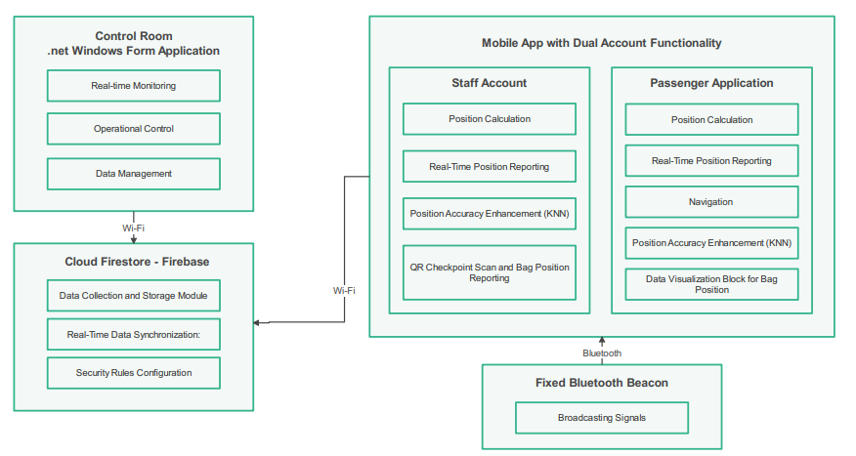
   1. **Block Diagram**

**Figure 1** Block Diagram

**3.2 Bluetooth Low Energy Beacon Device:**

The Fixed Beacon, constructed using ESP32 compounds, is a cornerstone component of the Travello indoor positioning system.

- This component is a physical device equipped with Bluetooth Low Energy (BLE) capabilities.

- It continuously broadcasts Bluetooth signals, aiding mobile devices equipped with Travello's application to detect and receive these signals.

* 1. **Cloud Firestore – Firebase Block:**

This block facilitates integration with Cloud Firestore, allowing the mobile app to store and retrieve data in real-time.

**Components:**

1. **Data Collection and Storage Module:**

* This module collects relevant data from the mobile app and prepares it for storage in Firestore.
* It may include functions for structuring data into documents and collections according to the Firestore data model.

1. **Real-Time Data Synchronization:**
   * This component ensures real-time synchronization of data between the mobile app and Firestore.
   * It utilizes Firestore's real-time database capabilities, such as listeners and subscriptions, to keep data updated across devices and platforms.
2. **Security Rules Configuration:**

* This configuration defines access control and security rules for Firestore.
* It specifies who can read, write, and modify data in the Firestore database, ensuring data security and integrity.
  1. **Control Room .NET Windows Form application**

The Control Room Application serves as the main interface for users to interact with the system.

The User Interface provides a graphical representation of the application's functionalities.

Components:

* Real-Time Monitoring: Allows users to interact with devices and systems in real-time.
* Data Management: Allows users to interact with devices, systems, tickets, and flight information in real-time.
* Manages storage, retrieval, and manipulation of historical data.
  1. **Mobile Application**

The mobile app provides a dual-account system catering to both staff members and users, each offering distinct functionalities tailored to their roles within the airport environment. Upon login, users are prompted to choose between a staff or user account, directing them to the appropriate interface based on their selection.

* + 1. **Staff Account:** Upon authentication, staff gain access to a specialized interface equipped with operational control features tailored to their roles.
* **Positions Calculation (Staff Positioning):** Staff members' positions within the airport premises are calculated and tracked using the mobile app.
* **Position Accuracy Enhancement with KNN**: The app integrates K-nearest neighbors (KNN) algorithms to enhance the accuracy of position calculations.
* **QR Code Generation for tracking Luggage:** Staff Generates qr code for each bag belongs to a ticket
* **Scanning Luggage at checkpoints:** Staff members can scan QR codes at designated checkpoints within the airport using the mobile app. Upon scanning, the app records the location of the checkpoint and associates it with relevant luggage information.
* **Customer Support:** Enable real time support chat between support agent and client
  + 1. **Passenger Account:** Upon authentication, users are directed to an interface designed to meet their specific needs as passengers navigating through the airport environment.
* **Data Visualization for flight information:** Passengers can get their flight information by entering their ticket number.
* **Data Visualization for Passenger Bag Position**: This feature enhances baggage tracking and minimizes the risk of luggage loss by allowing passengers to verify if their bags have successfully reached designated checkpoints or have been loaded onto the aircraft.
* **Navigating Through the Airport:** The app provides step-by-step directions and route guidance, helping passengers navigate efficiently to their desired destinations within the airport.
* **Find Family and Friends:** Where relative passengers can find each other by entering each other’s ticket number.
* **Customer Support:** Passengers can reach out real time support with the support team.

1. ***RSSI and Estimated Location***

We developed a mobile app equipped with Bluetooth functionality that allows clients to estimate their location based on RSSI. To further enhance precision, we've integrated the K-Nearest Neighbors (KNN) algorithm, ensuring robust and reliable location estimation.[6] To estimate the user's location involves analyzing how the RSSI signal strength varies in relation to the distance it travels. This approach relies on a path loss model to depict the correlation between RSSI and distance[21] as the following equation:

𝑅𝑆𝑆𝐼 = −10 ∗ 𝑚 ∗ 𝑙𝑔𝐷 + *A* (1)

𝐷 = 10[(𝐴−𝑅𝑆𝑆𝐼)/(10∗*n*)] (2)

where D is the distance. The parameters n is the path loss exponent, m and A are determined in real field tests. Line of sight experiments have been done to calculate these parameters.

We have also integrated a trilateration-based algorithm, as depicted in Figure 3. Utilizing the known positions of three reference sensors (B1, B2, and B3), we employ equations (3) and (4) to compute the beacon's location. In the Cartesian coordinate system, the coordinates of the three B1, B2, and B3 are denoted as (x1, y1), (x2, y2), and (x3, y3) respectively. The distances between the beacon (represented by the red dot D (x, y) in Figure (2) and the three sensors (D1, D2, and D3) are determined using the Euclidean distance equations provided below:

**Figure 2** Relation between RSSI and Distance [14]

$$\left\{\begin{matrix}D_{1}=\sqrt{{\left(x-x_{1}\right)}^{2}+{\left(y-y_{1}\right)}^{2}} \\ D_{2}=\sqrt{{\left(x-x_{2}\right)}^{2}+{\left(y-y_{2}\right)}^{2}} \\ D_{3}=\sqrt{{\left(x-x_{3}\right)}^{2}+{\left(y-y_{3}\right)}^{2}}\end{matrix}\right. (3)$$

Trilateration utilizes distance measurements from multiple readers to locate a target node. Each reader calculates its distance to the target using a propagation model. These distances form radii of circles centered at each reader's location. The target's location is where at least three of these circles intersect. Ideally, this intersection yields a single point, providing a unique solution. However, due to measurement errors, intersections may not result in a single point, but rather an area or no intersection at all.[20]

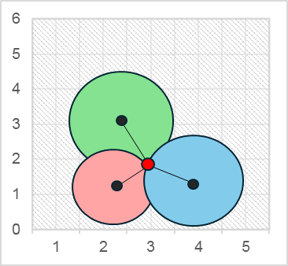

B3 (x3, y3)

B1 (x1, y1)

B2 (x2, y2)

**D1**

**D2**

**D3**

**P**

**Figure 3** Trilateration

$\left\{\begin{matrix}x=\frac{D_{1}^{2}-D_{2}^{2}+x_{2}^{2}}{2*x_{2}} \\ y=\frac{D_{1}^{2}-D_{3}^{2}+x_{3}^{2}+y_{3}^{2}}{2*y_{3}}-\frac{x_{3}}{y_{3}}*x\end{matrix}\right.$ (4)

The calculation of distance using RSSI values is influenced by various factors, including environmental conditions and obstacles. Additionally, air density plays a significant role in determining path loss, consequently impacting RSSI measurements.[15]

1. ***Classification Method***

**KNN** is a *nonparametric lazy supervised learning algorithm* mostly used for classification problems[16]. There are a lot to unpack there, but the two main properties of the K-NN that you need to know are:

* KNN is a nonparametric algorithm meaning that the model does not make any assumption regarding the distribution of the underlying data set.
* KNN is a **lazy learner technique** meaning that the algorithm does not learn the discriminative function from the training dataset. Instead, it stores (memorizes) the training dataset, so, technically, a lazy learner algorithm doesn’t have a training step, and it delays the data abstraction until it’s asked to make a prediction see.

*K* in *K*-Nearest Neighbors refers to the number of neighbors that one should take into consideration when predicting (voting for) the class of a new point. It will get clearer from the below example.

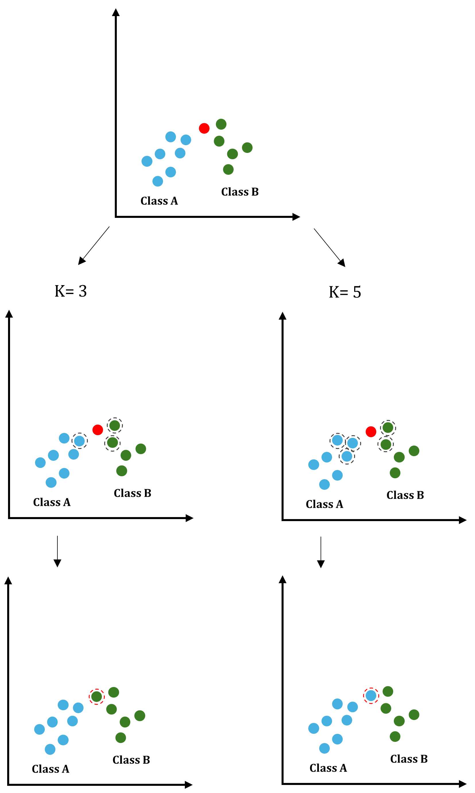**Features of KNN:**

New Point

**Figure 4** k for KNN Classifications

?

?

* Useful for nonlinear data because KNN is a nonparametric algorithm.
* Can be used for both classification and regression problems, even though mostly used for classification.

**problems we faced using KNN:**

* Real labeled dataset.
* Connect with flutter.
* Node, request, send.
* Slow prediction for large datasets.

**What benefits?**

Enhance of location and give us the accurate location through classification this point through its all RSSI by following these equations:[17]

* **Euclidean distance**
* **Manhattan distance**
* **Minkowski distance**
* **Hamming distance**

**Euclidean:** mostly use this distance measurement technique to find the distance between consecutive points. It is generally used to find the distance between two real-valued vectors.

$d=\sqrt{{(X_{2}-x_{1})}^{2}+{(y_{2}-y_{1})}^{2}}$& $d=\sqrt{\sum_{i=1}^{N}{{\left(Xi-Yi\right)}^{2}}}$

Indoor Positioning System (IPS) can determine someone’s position inside a building. This paper discusses how to do IPS using K-Nearest Neighbor (KNN) method, that also analyzes the accuracy. machine learning techniques have been utilized for indoor localization problems. For the specific use case of BLE positioning, the k Nearest Neighbors (KNN) algorithm and deep learning models have been employed in fingerprinting approaches by predicting the position based on measured signals on a set of reference points in a specific indoor space.

A set of experiments has been conducted to assess the performance of the proposed architectures. The main performance metric that we use is the Mean Euclidean Distance Error (MEDE), which is the mean distance between each predicted tag location 𝑃̂ 𝑖 and the corresponding true location 𝑃.

$$MEDE\left(P,Ṕ\right)= \frac{1}{N}\sum_{i=1}^{N}{d(P_{i},}Ṕ_{i})=\frac{1}{N}\sum_{i=1}^{N}{\sqrt{{\left(S_{i}-Ŝ_{i}\right)}^{2}+{\left(Y_{i}-Ŷ_{i}\right)}^{2}+{\left(Z_{i}-Ẑ_{i}\right)}^{2}}}$$

Machine learning models for indoor localization may suffer from low generalization potential, i.e., the model may have difficulties performing well with data cases never seen during training. In our study, we examined several generalization aspects, such as the spatial generalization potential of the models, i.e., to perform well in locations never seen during training and the generalization of different furniture configurations, e.g., furniture density and furniture material. Moreover, we investigated the robustness of the models to moderate dispositioning of the APs.

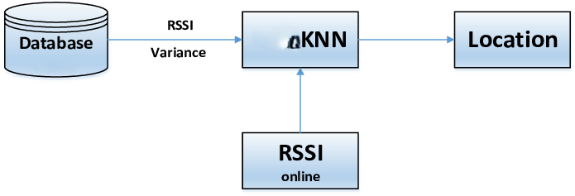

KNN

**Figure 5** K-NN Cycle

**Figure 6** K-NN Cycle [7]

1. **Experiments and results**

In our pursuit of refining the accuracy of indoor positioning system, we integrated the K-Nearest Neighbors (KNN) algorithm into our framework. This section outlines the experimental setup, the assessment of model performance, and the results obtained through the utilization of KNN.

**Experimental Setup**

To evaluate the efficacy of the KNN algorithm within our indoor positioning system, we designed a comprehensive experiment encompassing the following steps:[18]

1. **Data Collection:**

We collected a dataset consisting of various sensory inputs such as Bluetooth beacons, and mobile devices within our designated indoor environment. This dataset served as the foundation for training and testing our KNN model.

**Components:** 3 fixed points (ble beacons ‘ESP 32’), movable devices depend on Bluetooth signals.

**Experiment 1** we recorded 100 movable points in 20*5 m area.

**Experiment 2** We recorded 300 points over a duration of 10 minutes for a fixed point (2.5, 2.5).

**Experiment 3** recorded 500 movable points in 20*25m area.

1. **Data Preprocessing**:

Prior to applying the KNN algorithm, we conducted preprocessing steps to clean and normalize the collected data. This involved removing outliers, handling missing values, and standardizing features to ensure uniformity across the dataset.And splitting the data into 80% train and 20% test data using sklearn.model_selection and import train_test_split, and drop the target value from train and test - “x, y” axis - and get this result from our model and calculate the accuracy of model.

1. **Feature Selection**:

We carefully selected relevant features from the preprocessed dataset to be utilized as input variables for the KNN algorithm. These features encapsulated pertinent information crucial for accurate indoor positioning and tracking, when splitting the data into 80% train and 20% test data, and the train dataset carry the features “R1, R2,R3” and “location_id”.

1. **Model Training**:

The KNN model trained using a subset of the collected data “80% of our data”. We experimented with different values of 'k', the number of nearest neighbors considered during prediction, to optimize the model’s performance, in the training phase, we determined the optimal 'k' value for our KNN model through experimentation. Analyzing our data, we found that 'k' = 3 yielded the best results consistently. Therefore, we trained our model using this optimal 'k' value for enhanced predictive accuracy. To get the optimum ‘k’ we used sklearn.model_selection and import cross_val_score and KFold.

1. **Model Evaluation**:

Following training, we evaluated the trained KNN model using a separate testing dataset. This evaluation phase aimed to assess the accuracy and robustness of the model in predicting indoor Positions based on sensory inputs, we deduced from the experiments we made that the accuracy increase within the smaller ranges as the beacon

signal efficiently covered these ranges in addition to applying the KNN classification we got more satisfied results.

**4.1 Experiment 1:**

we recorded 100 movable points in 20*5 m area.

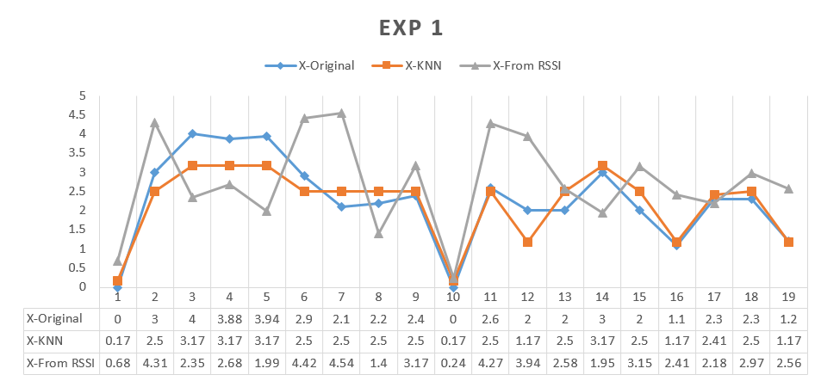The Graph recorded about 20 movable points in our environment based on (RSSI) values received from the three fixed point (BLE) devices, then we applied (KNN) approach to enhance the result as mentioned in the tables.

**Figure 7** X-axis from RSSI and after KNN

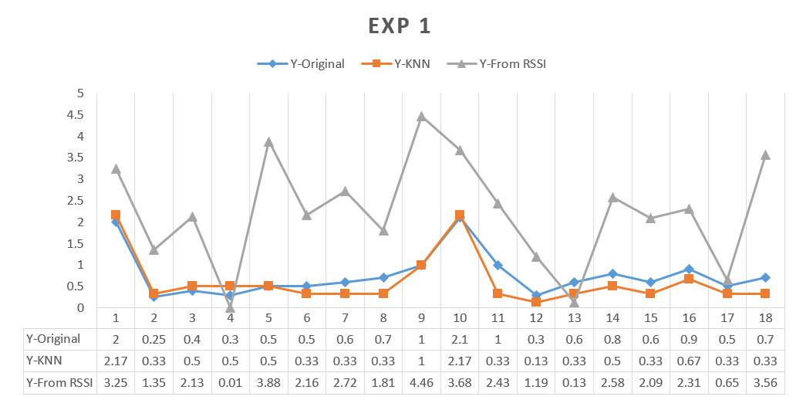

***Figure 8*** *Y-axis from RSSI and after KNN*

**Results of Experiment 1:**

Upon thorough experimentation and evaluation, our KNN-based indoor positioning system demonstrated promising results. By leveraging the KNN algorithm and fine-tuning its parameters, we achieved a mean absolute error of 62.00 units, signifying the accuracy of our model in predicting indoor positions. The graph depicting the error distribution across 20 testing points movable provides a visual representation of the model's performance, highlighting areas of improvement and potential future directions for optimization.

**Assessing Model Performance**

To gauge the effectiveness of our KNN-based indoor positioning system, we employed the Mean Absolute Error (MAE)[19] metric as a measure of predictive accuracy. Additionally, our model achieved an impressive accuracy rate of 93.45%, highlighting its capability to accurately predict indoor positions.

$$MAE= \frac{\sum_{i=1}^{N}{\left|Y_{i}-X_{i}\right|}}{n}$$

Where:

* 𝑛 represents the total number of observations or data points.
* ∣𝑦𝑖−𝑥𝑖∣ calculates the absolute difference between the predicted value 𝑥𝑖​ and the actual value 𝑦𝑖​ for each observation.
* $\sum_{i=1}^{N}{ }$ ​ denotes the summation of these absolute differences across all observations.
* Finally, the sum is divided by 𝑛, the total number of observations, to compute the average absolute error.

We applied the MAE and got the result value ≃ 62.00 and it means that this value of units, obtained through our experimentation, suggests that, on average, the predictions generated by our model deviated from the ground truth positions by 62 units. It is essential to contextualize this error value within the scale and requirements of the target variable. Depending on the specific application and user requirements, an MAE of 62 units may be deemed acceptable or necessitate further refinement.

Overall, the integration of the KNN algorithm into our indoor positioning system showcases its efficacy in enhancing predictive accuracy and facilitating real-time localization within indoor environments.

Any value of MAE Whether this is good or not depends on the specific application and user requirements. Generally, a lower MAE value is preferred, suggesting that the model's predictions are closer to the ground truth. If the MAE becomes bigger, the model's performance will likely worsen, and it may be necessary to implement improvements.

**4.2 Experiment 2:**

Applying in area 5m in width and 5m in length. At coordinates (2.5, 2.5), with 3 fixed points (BLE beacons ‘ESP 32’) , We recorded 300 points over a duration of 10 minutes for the same point. After classification process using (KNN) and accuracy 93% and approach the error rate decreased as shown in Fig 9.

**Figure 9** Appling KNN over duration of 10 minutes

**Sample of recorded data**

|  |  |  |  |  |
| --- | --- | --- | --- | --- |
| **X** | **Y** | **RSSI1** | **RSSI2** | **RSSI3** |
| 3.47 | 4.24 | -67 | -77 | -62 |
| 0.4 | 2.01 | -66 | -78 | -64 |
| 0.78 | 3.98 | -62 | -79 | -58 |
| 4.97 | 4.5 | -66 | -79 | -63 |
| 4.97 | 4.5 | -66 | -79 | -63 |
| 4.18 | 4.51 | -68 | -80 | -63 |
| 3.79 | 2.13 | -64 | -75 | -64 |

|  |  |
| --- | --- |
| **X** | **Y** |
| 2.5 | 2 |
| 2.5 | 2.5 |
| 2.5 | 2.8 |
| 2.7 | 2.8 |
| 3 | 2.3 |
| 3.3 | 1.7 |
| 3.7 | 1.8 |

**Calibrated values**

**Enhanced values**

**4.3 Experiment 3:**

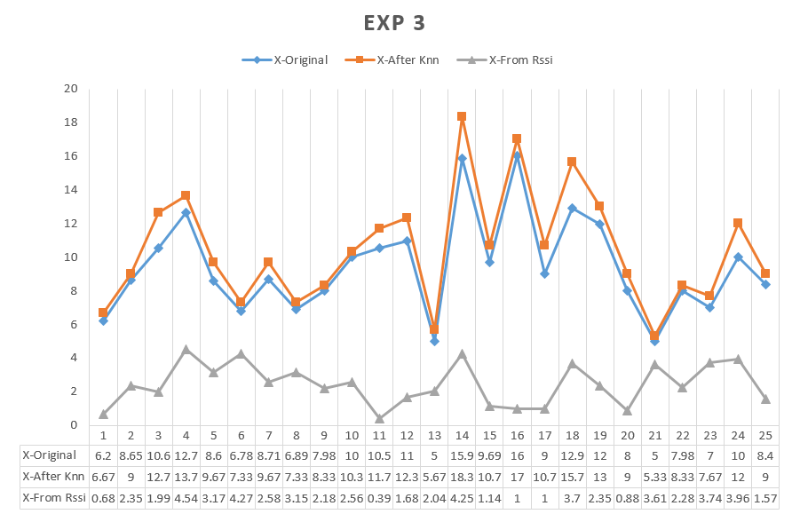we recorded about 500 movable points with 6 fixed points (BLE beacons ‘ESP 32’ but show in a graph sample of them about 25 points and show in our environment based on (RSSI) values received from the three fixed point (BLE) devices, then we applied (KNN) approach to enhance the result as mentioned in the tables, and the accuracy in this case 93%.

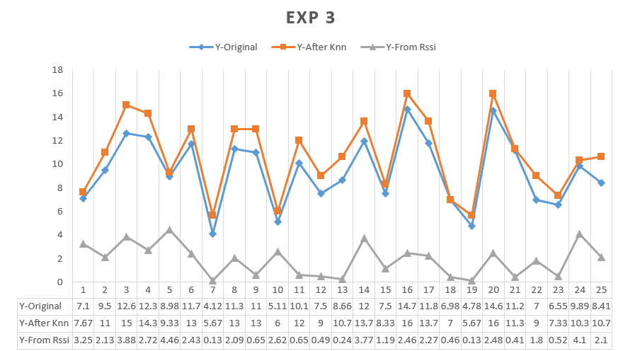

**Figure 10** Apply KNN on Large scale, X-axis RSSI and after KNN

**Figure 11** Apply KNN on Large scale, Y-axis RSSI and after KNN

1. **Conclusion**

In conclusion, this paper has presented an in-depth exploration of indoor positioning systems (IPS) and the advancements made in enhancing their accuracy and reliability. With the limitations of GPS in indoor environments becoming increasingly evident, IPS technologies have emerged as indispensable tools across various domains, including navigation assistance, inventory management, and public safety.

The integration of Bluetooth Low Energy (BLE) technology within IPS frameworks has shown significant promise, offering a balance between cost-effectiveness, energy efficiency, and accuracy. By leveraging BLE beacons and the Receiver Signal Strength Indicator (RSSI), our research endeavors to refine indoor positioning capabilities, overcoming challenges such as unstable signal strengths and signal interference.

The proposed approach, incorporating a novel coarse-to-fine positioning methodology, integrates weighted K-Nearest Neighbors (KNN) and adaptive bandwidth mean shift techniques. Through experimentation, we have demonstrated the efficacy of the KNN algorithm in enhancing predictive accuracy, achieving an impressive accuracy rate of 93.45%. Additionally, the Mean Absolute Error (MAE) metric provides insights into the predictive performance of our model, highlighting areas for further refinement and optimization.

Our experimental results underscore the potential of KNN-based indoor positioning system to deliver accurate and reliable location-based services across diverse indoor environments. As we continue to innovate and refine IPS methodologies, our research contributes to the ongoing evolution of indoor localization technologies, paving the way for enhanced applications in various sectors, including public safety, healthcare, and logistics.

In essence, the fusion of advanced algorithms, such as KNN, with emerging technologies like BLE, holds immense promise for the future of indoor positioning systems, enabling seamless navigation and localization experiences in indoor spaces worldwide.

1. **References**

[1] Henrik Blunck, Mikkel Baun Kjærgaard, Torben Godsek, Thomas Toftkjær, Dan Hyltoft Lund, Kaj Grønbæk, “Empirical Analysis and Characterization ofIndoor GPS Signal Fading and MultipathConditions”, 2009.

[2] Ching-Sheng Wang, Chien-Liang Chen, You-Ming Guo, “A Real-Time Indoor Positioning System Based on RFID and Kinect” In J. J. Park, L. T. Yang, & C. Lee (Eds.), Information Technology Convergence (pp. 575-585), 2013.

[3] Fen Liu, Jing Liu, Yuqing Yin, Wenhan Wang, “A Survey on WiFi-Based Indoor Positioning Technologies”, *IET Communications*, 2020.

[4] Hao Zhang, Qing Wang, Chao Yan, Jiujing Xu, Bo Zhang, “Research on UWB Indoor Positioning Algorithm under the Influence of Human Occlusion and Spatial NLOS”, Remote Sens, 2022.

[5] Uday Agarwal, “Indoor Positioning with BLE Beacons”, 2017.

[6] Lu Bai, Fabio Ciravegna, Raymond Bond, Maurice Mulvenna, “A Low-Cost Indoor Positioning System Using Bluetooth Low Energy”, in IEEE Access, vol. 8, pp. 136858-136871, 2020.

[7] Yu-Chi Pu, Pei-Chun You, “Indoor positioning system based on BLE location fingerprinting with classification approach”, Applied Mathematical Modelling, vol. 62, pp. 654-663, 2018.

[8] J. Blumenthal, R. Grossmann, F. Golatowski and D. Timmermann, "Weighted Centroid Localization in Zigbee-based Sensor Networks," 2007 IEEE International Symposium on Intelligent Signal Processing, Alcala de Henares, Spain, 2007, pp. 1-6, doi: 10.1109/WISP.2007.4447528, 2007.

[9] R. Faragher and R. Harle, "Location Fingerprinting with Bluetooth Low Energy Beacons," in IEEE Journal on Selected Areas in Communications, vol. 33, no. 11, pp. 2418-2428, Nov. 2015.

[10] K. Yamano, K. Tanaka, M. Hirayama, E. Kondo, Y. Kimuro and M. Matsumoto, "Self-localization of mobile robots with RFID system by using support vector machine," 2004 IEEE/RSJ International Conference on Intelligent Robots and Systems (IROS) (IEEE Cat. No.04CH37566), Sendai, 2004, pp. 3756-3761 vol.4, 2004.

[11] H. Liu, H. Darabi, P. Banerjee and J. Liu, "Survey of Wireless Indoor Positioning Techniques and Systems," in IEEE Transactions on Systems, Man, and Cybernetics, Part C (Applications and Reviews), vol. 37, no. 6, pp. 1067-1080, Nov. 2007.

[12] P. Bahl and V. N. Padmanabhan, "RADAR: an in-building RF-based user location and tracking system," Proceedings IEEE INFOCOM 2000. Conference on Computer Communications. Nineteenth Annual Joint Conference of the IEEE Computer and Communications Societies (Cat. No.00CH37064), 2000, pp. 775-784.

[13] A. Thaljaoui, T. Val, N. Nasri and D. Brulin, "BLE localization using RSSI measurements and iRingLA," 2015 IEEE International Conference on Industrial Technology (ICIT), Seville, Spain, 2015, pp. 2178-2183.

[14] S. Cortesi, M. Dreher and M. Magno, "Design and Implementation of an RSSI-Based Bluetooth Low Energy Indoor Localization System," 2021 17th International Conference on Wireless and Mobile Computing, Networking and Communications (WiMob), Bologna, Italy, 2021, pp. 163-168.

[15] R. Kanan and O. Elhassan, "A Combined Batteryless Radio and WiFi Indoor Positioning for Hospital Nursing," in *Journal of Communications Software and Systems*, vol. 12, no. 1, pp. 34-44, March 2016.

[16] K. Taunk, S. De, S. Verma and A. Swetapadma, "A Brief Review of Nearest Neighbor Algorithm for Learning and Classification," 2019 International Conference on Intelligent Computing and Control Systems (ICCS), Madurai, India, 2019, pp. 1255-1260.

[17] Kittipong Chomboon, Pasapitch Chujai, Pongsakorn Teerarassammee, Kittisak Kerdprasop, Nittaya Kerdprasop, “An Empirical Study of Distance Metrics for k-Nearest Neighbor Algorithm”, *In International Conference on Industrial Application Engineering, 2015.*

[18] Xuanyu Zhu, “Indoor Localization Based on Optimized KNN”, *Network and Communication Technologies; Vol. 5, No. 2,* *Published by Canadian Center of Science and Education, 2020.*

[19] Adrià Molina, Pau Riba, Lluis Gomez, Oriol Ramos Terrades, Josep Lladós, “Date Estimation in the Wild of Scanned Historical Photos: An Image Retrieval Approach” *In Computer Vision Center and Computer Science Department, Universitat Autonoma de Barcelona, Catalunya, 2021.*

[20] C. S. Mouhammad, A. Allam, M. Abdel-Raouf, E. Shenouda and M. Elsabrouty, "BLE Indoor Localization based on Improved RSSI and Trilateration," 2019 7th International Japan-Africa Conference on Electronics, Communications, and Computations, (JAC-ECC), Alexandria, Egypt, 2019, pp. 17-21.

[21] Li G, Geng E, Ye Z, Xu Y, Lin J, Pang Y., “Indoor Positioning Algorithm Based on the Improved RSSI Distance Model” Sensors (Basel), 2018.

[22] Wenzhao Shu, Shuai Wang, “An Indoor Positioning System of Bluetooth AOA Using Uniform Linear Array Based on Two-point Position Principle”, *In IEEE SENSORS JOURNAL, VOL.30, NO.8,* 2022.

[23] S.J. Hayward, K. van Lopik, C. Hinde, A.A. West, “A Survey of Indoor Location Technologies, Techniques and Applications in Industry”, *Internet of Things,Volume 20,* 2022.

[24] Zhang, J., Yi, Q., Huang, L., Yang, Z., Cheng, J., Zhang, H, “Research on None-Line-of-Sight/Line-of-Sight Identification Method Based on Convolutional Neural Network-Channel Attention Module.”, Sensors, 2023.

[25] P. Spachos and K. Plataniotis, "BLE Beacons in the Smart City: Applications, Challenges, and Research Opportunities," in IEEE Internet of Things Magazine, vol. 3, no. 1, pp. 14-18, March 2020.

[26] Röbesaat J, Zhang P, Abdelaal M, Theel O., “An Improved BLE Indoor Localization with Kalman-Based Fusion: An Experimental Study”, Sensors (Basel). 2017 Apr 26.